Computer Graphics Laboratory
Assignment No.1

Title:- Write C++ program to draw a concave polygon and fill it with desired color using scan fill algorithm.

Program:-

#include <iostream>
#include <graphics.h>
#include <stdlib.h>
using namespace std;
class point
{
public:
int x,y;
};
class poly
{
private:
point p[20];
int inter[20],x,y;
int v,xmin,ymin,xmax,ymax;
public:
int c;
void read();
void calcs();
void display();
void ints(float);
void sort(int);
};
void poly::read()
{
int i;
cout<<"\n Scan Fill Algorithm ";
cout<<"\n Enter Number Of Vertices Of Polygon: ";
cin>>v;
if(v>2)
{
for(i=0;i<v; i++)
{
cout<<"\nEnter co-ordinate no. "<<i+1<<" : ";
cout<<"\n\tx"<<(i+1)<<"=";
cin>>p[i].x;
cout<<"\n\ty"<<(i+1)<<"=";
cin>>p[i].y;
}
p[i].x=p[0].x;
p[i].y=p[0].y;
xmin=xmax=p[0].x;
ymin=ymax=p[0].y;
}
else
cout<<"\n Enter valid no. of vertices.";
}
void poly::calcs()
{
for(int i=0;i<v;i++)
{
if(xmin>p[i].x)
xmin=p[i].x;
if(xmax<p[i].x)
xmax=p[i].x;
if(ymin>p[i].y)
ymin=p[i].y;
if(ymax<p[i].y)
ymax=p[i].y;
}
}
void poly::display()
{
int ch1;
char ch='y';
float s,s2;
do
{
cout<<"\n\nMENU:";
cout<<"\n\n\t1 . Scan line Fill ";
cout<<"\n\n\t2 . Exit ";
cout<<"\n\nEnter your choice:";
cin>>ch1;
switch(ch1)
{
case 1:
s=ymin+0.01;
delay(100);
cleardevice();
while(s<=ymax)
{
ints(s);
sort(s);
s++;
}
break;
case 2:
exit(0);
}
cout<<"Do you want to continue?: ";
cin>>ch;
}while(ch=='y' || ch=='Y');
}
void poly::ints(float z)
{
int x1,x2,y1,y2,temp;
c=0;
for(int i=0;i<v;i++)
{
x1=p[i].x;
y1=p[i].y;
x2=p[i+1].x;
y2=p[i+1].y;
if(y2<y1)
{
temp=x1;
x1=x2;
x2=temp;
temp=y1;
y1=y2;
y2=temp;
}
if(z<=y2&&z>=y1)
{
if((y1-y2)==0)
x=x1;
else
{
x=((x2-x1)*(z-y1))/(y2-y1);
x=x+x1;
}
if(x<=xmax && x>=xmin)
inter[c++]=x;
}
}
}
void poly::sort(int z)
{
int temp,j,i;
for(i=0;i<v;i++)
{
line(p[i].x,p[i].y,p[i+1].x,p[i+1].y);
}
delay(100);
for(i=0; i<c;i+=2)
{
delay(100);
line(inter[i],z,inter[i+1],z);
}
}
int main() //main
{
int cl;
int gd=DETECT,gm;
initgraph(&gd,&gm,NULL);
cleardevice();
poly x;
x.read();
x.calcs();
cleardevice();
cout<<"\n\tEnter The Color You Want :(In Range 0 To 15 )->";
cin>>cl;
setcolor(cl);
x.display();
closegraph();
getch();
return 0;
}
Output:-
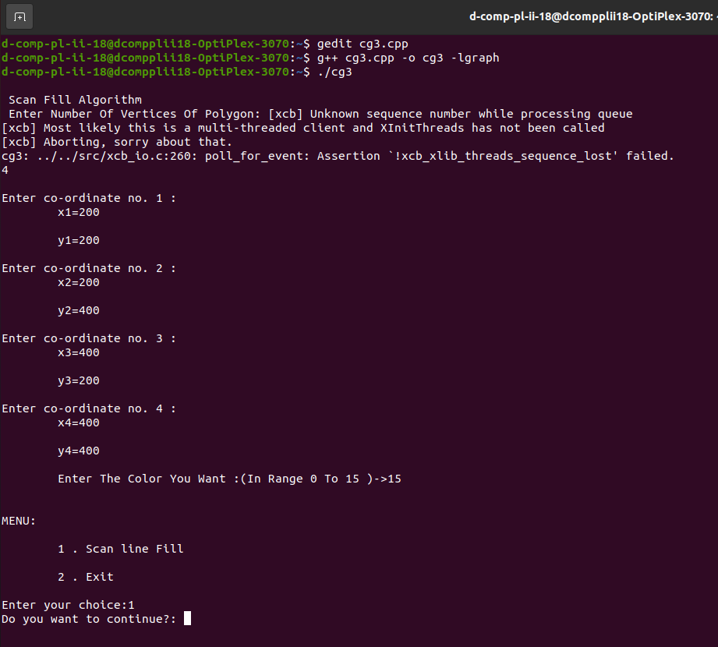
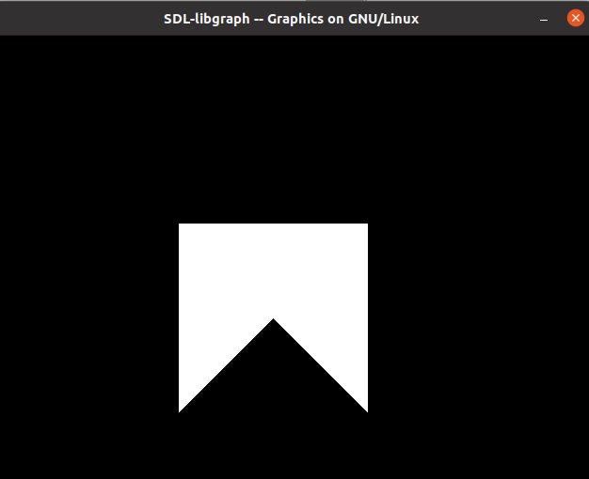

Assignment no.2

Title:- Write C++ program to implement Cohen Southerland line clipping algorithm.
Program:-
#include<iostream>
#include<stdlib.h>
#include<math.h>
#include<graphics.h>
using namespace std;
class Coordinate
{
public:
int x,y;
char code[4];
};
class Lineclip
{
public:
Coordinate PT;
void drawwindow();
void drawline(Coordinate p1,Coordinate p2);
Coordinate setcode(Coordinate p);
int visibility(Coordinate p1,Coordinate p2);
Coordinate resetendpt(Coordinate p1,Coordinate p2);
};
int main()
{
Lineclip lc;
int gd = DETECT,v,gm;
Coordinate p1,p2,p3,p4,ptemp;

cout<<"\n Enter x1 and y1\n";
cin>>p1.x>>p1.y;
cout<<"\n Enter x2 and y2\n";
cin>>p2.x>>p2.y;

initgraph(&gd,&gm,NULL);
lc.drawwindow();
delay(2000);

lc.drawline (p1,p2);
delay(2000);
cleardevice();

delay(2000);
p1=lc.setcode(p1);
p2=lc.setcode(p2);
v=lc.visibility(p1,p2);
delay(2000);

switch(v)
{
case 0: lc.drawwindow();
delay(2000);
lc.drawline(p1,p2);
break;
case 1:lc.drawwindow();
delay(2000);
break;
case 2:p3=lc.resetendpt(p1,p2);
p4=lc.resetendpt(p2,p1);
lc.drawwindow();
delay(2000);
lc.drawline(p3,p4);
break;
}
delay(2000);
closegraph();
}
void Lineclip::drawwindow()
{
line(150,100,450,100);
line(450,100,450,350);
line(450,350,150,350);
line(150,350,150,100);
}
void Lineclip::drawline(Coordinate p1,Coordinate p2)
{
line(p1.x,p1.y,p2.x,p2.y);
}
Coordinate Lineclip::setcode(Coordinate p)
{
Coordinate ptemp;
if(p.y<100)
ptemp.code[0]='1';
else
ptemp.code[0]='0';
if(p.y>350)
ptemp.code[1]='1';
else
ptemp.code[1]='0';
if(p.x>450)
ptemp.code[2]='1';
else
ptemp.code[2]='0';
if(p.x<150)
ptemp.code[3]='1';
else
ptemp.code[3]='0';
ptemp.x=p.x;
ptemp.y=p.y;
return(ptemp);
};
int Lineclip:: visibility(Coordinate p1,Coordinate p2)
{
int i,flag=0;
for(i=0;i<4;i++)
{
if(p1.code[i]!='0' || (p2.code[i]=='1'))
flag='0';
}
if(flag==0)
return(0);
for(i=0;i<4;i++)
{
if(p1.code[i]==p2.code[i] && (p2.code[i]=='1'))
flag='0';
}
if(flag==0)
return(1);
return(2);
}
Coordinate Lineclip::resetendpt(Coordinate p1,Coordinate p2)
{
Coordinate temp;
int x,y,i;
float m,k;
if(p1.code[3]=='1')
x=150;
if(p1.code[2]=='1')
x=450;
if((p1.code[3]=='1') || (p1.code[2])=='1')
{
m=(float)(p2.y-p1.y)/(p2.x-p1.x);
k=(p1.y+(m*(x-p1.x)));
temp.y=k;
temp.x=x;
for(i=0;i<4;i++)
temp.code[i]=p1.code[i];
if(temp.y<=350 && temp.y>=100)
return (temp);
}
if(p1.code[0]=='1')
y=100;
if(p1.code[1]=='1')
y=350;
if((p1.code[1]=='1') || (p1.code[1]=='1'))
{
m=(float)(p2.y-p1.y)/(p2.x-p1.x);
k=(float)p1.x+(float)(y-p1.y)/m;
temp.x=k;
temp.y=y;
for(i=0;i<4;i++)
temp.code[i]=p1.code[i];
return(temp);
}
else
return(p1);
}
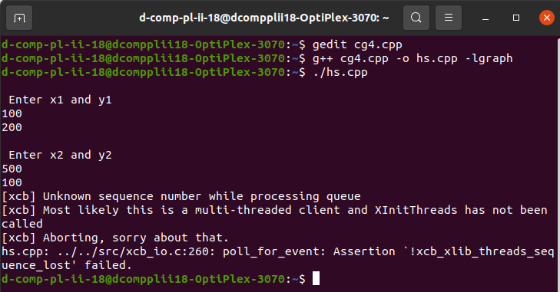
Output:-
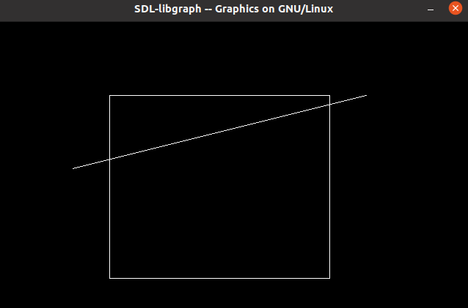
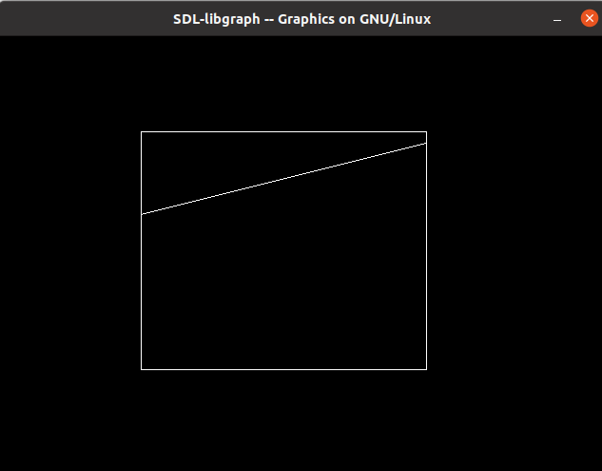
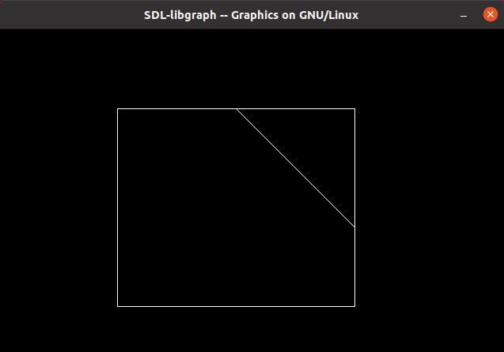
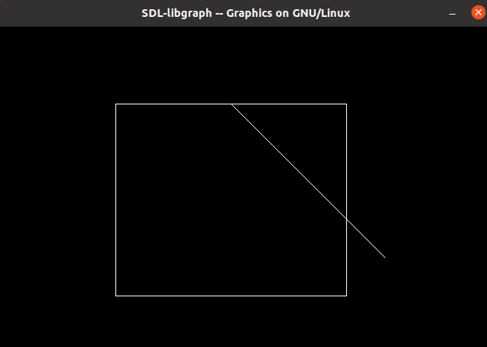
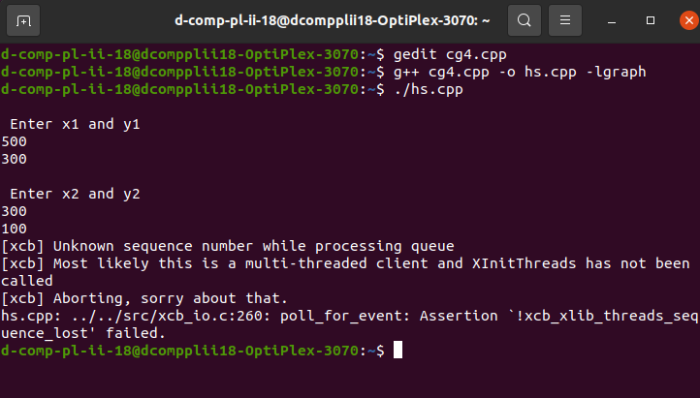

Assignment no.3

Title:- Write C++ program to draw the following pattern. Use DDA and Bresenham‘s Line drawing algorithm.

Program:-
#include <iostream>
# include <graphics.h>
# include <stdlib.h>
using namespace std;
class dcircle
{
private:
int x0, y0;
public:
dcircle()
{
x0=0;
y0=0;
}
void setoff(int xx, int yy)
{
x0=xx;
y0=yy;
}
void drawc(int x1, int y1, int r)
{
float d;
int x,y;
x=0;
y=r;
d=3-2*r;
do
{
putpixel(x1+x0+x, y0+y-y1, 15);
putpixel(x1+x0+y, y0+x-y1,15);
putpixel(x1+x0+y, y0-x-y1,15);
putpixel(x1+x0+x,y0-y-y1,15);
putpixel(x1+x0-x,y0-y-y1,15);
putpixel(x1+x0-y, y0-x-y1,15);
putpixel(x1+x0-y, y0+x-y1,15);
putpixel(x1+x0-x, y0+y-y1,15);
if (d<=0)
{
d = d+4*x+6;
}
else
{
d=d+4*(x-y)+10;
y=y-1;
}
x=x+1;
}
while(x<y);
}
};
class pt
{
protected:
int xco, yco,color;
public:
pt()
{
xco=0,yco=0,color=15;
}
void setco(int x, int y)
{
xco=x;
yco=y;
}
void setcolor(int c)
{
color=c;
}
void draw()
{
putpixel(xco,yco,color);
}
};
class dline:public pt
{
private: int x2, y2;
public:
dline():pt()
{
x2=0;
y2=0;
}
void setline(int x, int y, int xx, int yy)
{
pt::setco(x,y);
x2=xx;
y2=yy;
}
void drawl( int colour)
{
float x,y,dx,dy,length;
int i;
pt::setcolor(colour);
dx= abs(x2-xco);
dy=abs(y2-yco);
if(dx>=dy)
{
length= dx;
}
else
{
length= dy;
}
dx=(x2-xco)/length;
dy=(y2-yco)/length;
x=xco+0.5;
y=yco+0.5;
i=1;
while(i<=length)
{
pt::setco(x,y);
pt::draw();
x=x+dx;
y=y+dy;
i=i+1;
}
pt::setco(x,y);
pt::draw();
}
};
int main()
{
int gd=DETECT, gm;
initgraph(&gd, &gm, NULL);
int x,y,r, x1, x2, y1, y2, xmax, ymax, xmid, ymid, n, i;
dcircle c;
cout<<"\nEnter coordinates of centre of circle : ";
cout<<"\nEnter the value of x : ";
cin>>x;
cout<<"\nEnter the value of y : ";
cin>>y;
cout<<"\nEnter the value of radius : ";
cin>>r;
xmax= getmaxx();
ymax=getmaxy();
xmid=xmax/2;
ymid=ymax/2;
setcolor(1);
c.setoff(xmid,ymid);
line(xmid, 0, xmid, ymax);
line(0,ymid,xmax,ymid);
setcolor(15);
c.drawc(x,y,r);
pt p1;
p1.setco(100,100);
p1.setcolor(14);
dline l;
l.setline(x1+xmid, ymid-y1, x2+xmid, ymid-y2);
cout<<"Enter Total Number of lines : ";
cin>>n;
for(i=0;i<n;i++)
{
cout<<"Enter co-ordinates of point x1 : ";
cin>>x1;
cout<<"enter coordinates of point y1 : ";
cin>>y1;
cout<<"Enter co-ordinates of point x2 : ";
cin>>x2;
cout<<"enter coordinates of point y2 : ";
cin>>y2;
l.setline(x1+xmid, ymid-y1, x2+xmid, ymid-y2);
l.drawl(15);
}
cout<<"\nEnter coordinates of centre of circle : ";
cout<<"\nEnter the value of x : ";
cin>>x;
cout<<"\nEnter the value of y : ";
cin>>y;
cout<<"\nEnter the value of radius : ";
cin>>r;
setcolor(5);
c.drawc(x,y,r);
getch();
delay(2000);
closegraph();
return 0;
}

Output:-
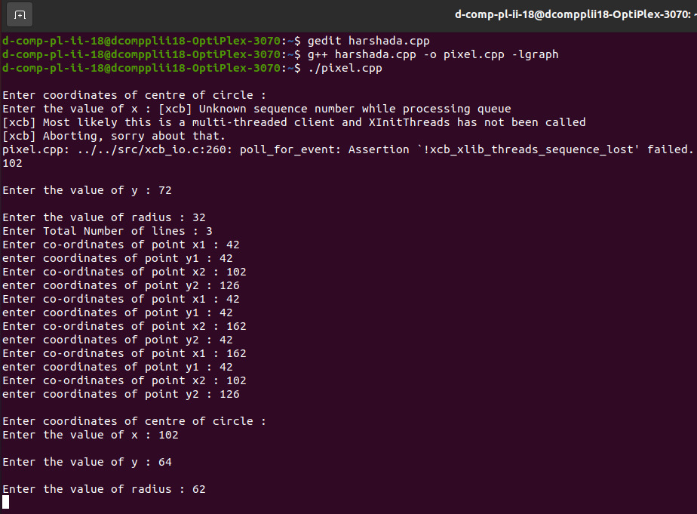

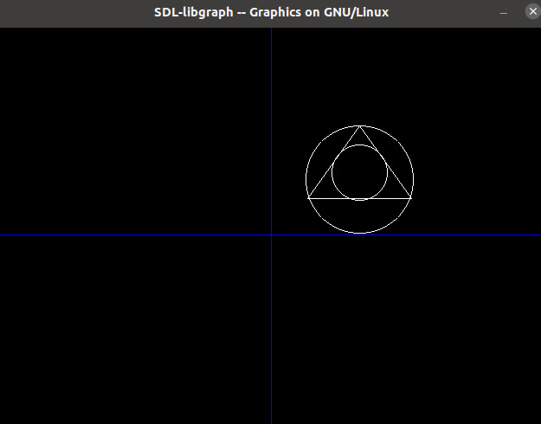

Assignment No.4

Title:- Write C++ program to draw 2-D object and perform following
basic transformations,
a) Scaling b) Translation c) Rotation. Use operator overloading
Program:-
#include<iostream>
#include<graphics.h>
#include<math.h>
using namespace std;
class transform
{
public:
int m,a[20][20],c[20][20];
int i,j,k;
public:
void object();
void accept();
void operator *(float b[20][20])
{
for(int i=0;i<m;i++)
{
for(int j=0;j<m;j++)
{
c[i][j]=0;
for(int k=0;k<m;k++)
{
c[i][j]=c[i][j]+(a[i][k]*b[k][j]);
}
}
}
}
};
void transform::object()
{
int gd,gm;
gd=DETECT;
initgraph(&gd,&gm,NULL);
line(300,0,300,600);
line(0,300,600,300);
for( i=0;i<m-1;i++)
{
line(300+a[i][0],300-a[i][1],300+a[i+1][0],300-a[i+1][1]);
}
line(300+a[0][0],300-a[0][1],300+a[i][0],300-a[i][1]);
for( i=0;i<m-1;i++)
{
line(300+c[i][0],300-c[i][1],300+c[i+1][0],300-c[i+1][1]);
}
line(300+c[0][0],300-c[0][1],300+c[i][0],300-c[i][1]);
int temp;
cout << "Press 1 to continue";
cin >> temp;
closegraph();
}
void transform::accept()
{
cout<<"\n";
cout<<"Enter the Number Of Edges:";
cin>>m;
cout<<"\nEnter The Coordinates :";
for(int i=0;i<m;i++)
{
for(int j=0;j<3;j++)
{
if(j>=2)
a[i][j]=1;
else
cin>>a[i][j];
}
}
}
int main()
{
int ch,tx,ty,sx,sy;
float deg,theta,b[20][20];
transform t;
t.accept();
cout<<"\nEnter your choice";
cout<<"\n1.Translation"
"\n2.Scaling"
"\n3.Rotation";
cin>>ch;
switch(ch)
{
case 1: cout<<"\nTRANSLATION OPERATION\n";
cout<<"Enter value for tx and ty:";
cin>>tx>>ty;
b[0][0]=b[2][2]=b[1][1]=1;
b[0][1]=b[0][2]=b[1][0]=b[1][2]=0;
b[2][0]=tx;
b[2][1]=ty;
t * b;
t.object();
break;
case 2: cout<<"\nSCALING OPERATION\n";
cout<<"Enter value for sx,sy:";
cin>>sx>>sy;
b[0][0]=sx;
b[1][1]=sy;
b[0][1]=b[0][2]=b[1][0]=b[1][2]=0;
b[2][0]=b[2][1]=0;
b[2][2] = 1;
t * b;
t.object();
break;
case 3: cout<<"\nROTATION OPERATION\n";
cout<<"Enter value for angle:";
cin>>deg;
theta=deg*(3.14/100);
b[0][0]=b[1][1]=cos(theta);
b[0][1]=sin(theta);
b[1][0]=sin(-theta);
b[0][2]=b[1][2]=b[2][0]=b[2][1]=0;
b[2][2]=1;
t * b;
t.object();
break;
default:
cout<<"\nInvalid choice";
}
getch();
return 0;
}
Output:-
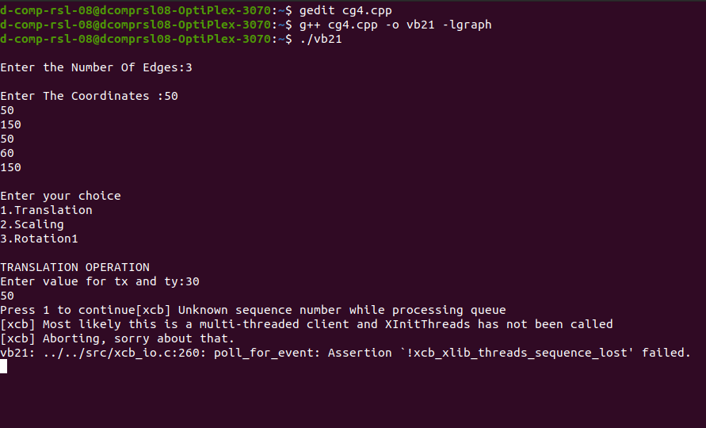

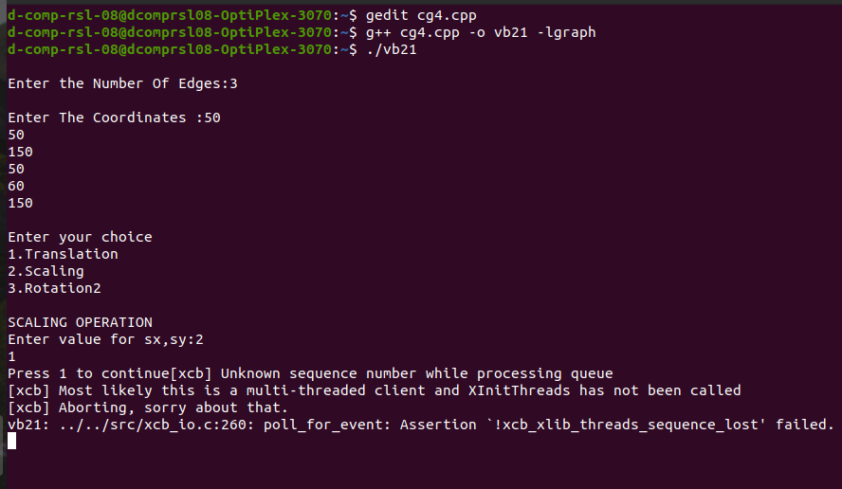
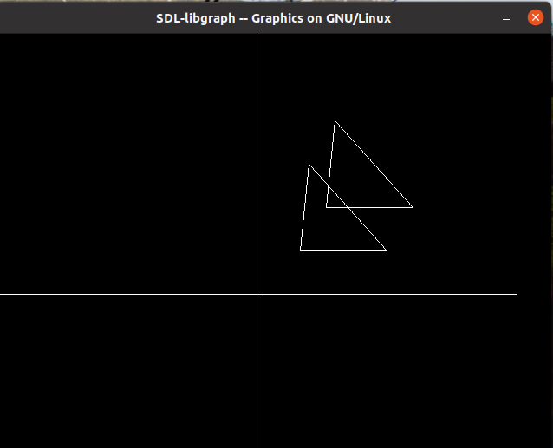

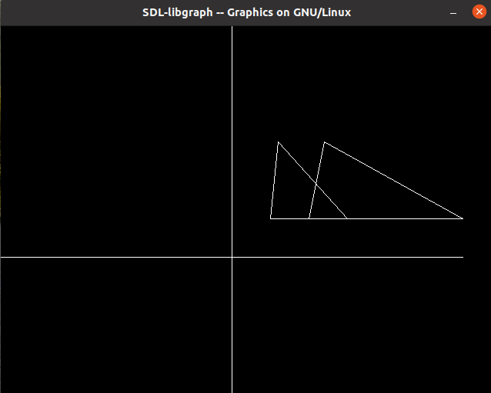

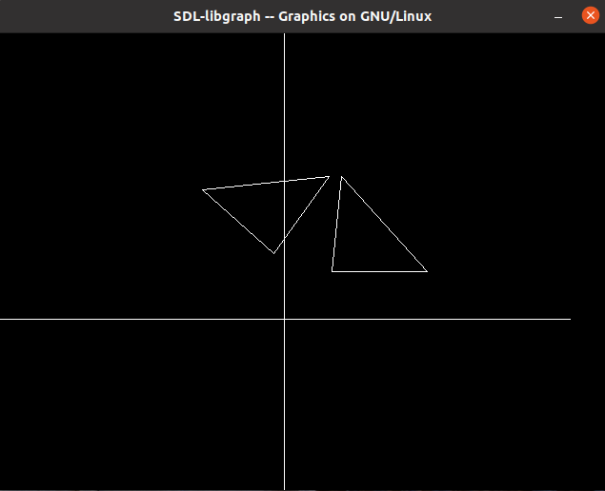
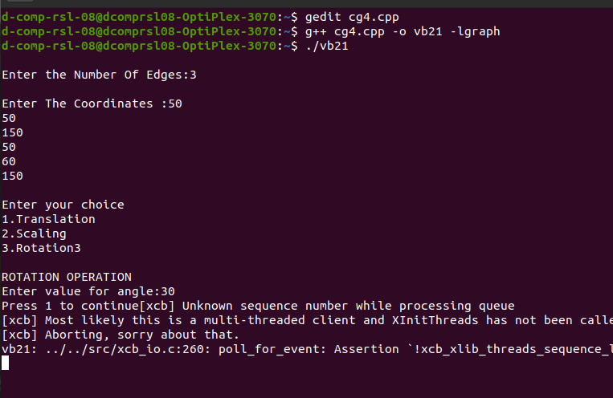

Assignment no.5

Title:-Write C++ program to generate Hilbert curve using concept of fractals (use constructor).
Program:-
#include<iostream>
#include<stdlib.h>
#include<graphics.h>
#include<math.h>
using namespace std;
void move(int j, int h, int &x, int &y)
{
if(j==1)
y=y-h;
else if(j==2)
x+=h;
else if(j==3)
y+=h;
else if(j==4)
x-=h;
lineto(x,y);
}
void hilbert(int r, int d, int l, int u, int i, int h, int &x, int &y)
{
if(i>0)
{
i--;
hilbert(d,r,u,l,i,h,x,y);
move(r,h,x,y);
hilbert(r,d,l,u,i,h,x,y);
move(d,h,x,y);
hilbert(r,d,l,u,i,h,x,y);
move(l,h,x,y);
hilbert(u,l,d,r,i,h,x,y);
}
}
int main()
{
int n,x1,y1;
int x0=50,y0=150,x,y,h=10,r=2,d=3,l=4,u=1;

cout<<"\n Give value of n:";
cin>>n;
x=x0;
y=y0;
int gm, gd=DETECT;
initgraph(&gd,&gm,NULL);
moveto(x,y);
hilbert(r,d,l,u,n,h,x,y);
delay(20000);
closegraph();
return 0;
}
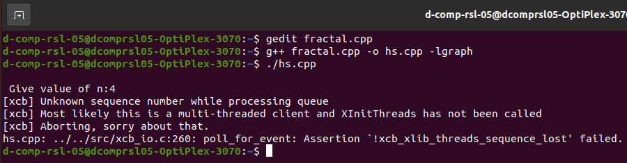
Output:-

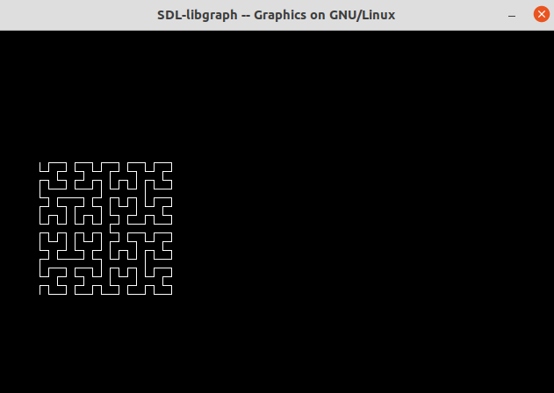

Assignment no.6

Title:- Write OpenGL program to draw Sun Rise and Sunset.
Program:-
#include<iostream>
#include<stdlib.h>
#ifdef __APPLE__
#include<openGL/openGL.h>
#include<GLUT/glut.h>
#else
#include<GL/glut.h>
#endif
using namespace std;
float ballX = -0.8f;
float ballY = -0.3f;
float ballZ = -1.2f;
float colR=3.0;
float colG=1.5;
float colB=1.0;
float bgColR=0.0;
float bgColG=0.0;
float bgColB=0.0;
static int flag=1;

void drawBall(void)
{
glColor3f(colR,colG,colB);
glTranslatef(ballX,ballY,ballZ);
glutSolidSphere (0.05, 30, 30);
}

void drawAv(void)
{
glBegin(GL_POLYGON);
glColor3f(1.0,1.0,1.0);
glVertex3f(-0.9,-0.7,-1.0);
glVertex3f(-0.5,-0.1,-1.0);
glVertex3f(-0.2,-1.0,-1.0);
glVertex3f(0.5,0.0,-1.0);
glVertex3f(0.6,-0.2,-1.0);
glVertex3f(0.9,-0.7,-1.0);
glEnd();
}
void drawClouds(){}

void keyPress(int key, int x, int y)
{
if(key==GLUT_KEY_RIGHT)
ballX -= 0.05f;
if(key==GLUT_KEY_LEFT)
ballX += 0.05f;
glutPostRedisplay();
}

void initRendering()
{
glEnable(GL_DEPTH_TEST);
glEnable(GL_COLOR_MATERIAL);
glEnable(GL_LIGHTING);
glEnable(GL_LIGHT0);
glEnable(GL_LIGHT1);
glEnable(GL_NORMALIZE);

}

void handleResize(int w, int h)
{
glViewport(0, 0, w, h);
glMatrixMode(GL_PROJECTION);
glLoadIdentity();
gluPerspective(45.0,(double)w / (double)h, 1.0, 200.0);
}

void drawScene()
{
glClear(GL_COLOR_BUFFER_BIT|GL_DEPTH_BUFFER_BIT);
glClearColor(bgColR,bgColG,bgColB,0.0);
glMatrixMode(GL_MODELVIEW);
glLoadIdentity();
GLfloat ambientColor[] = {0.2f, 0.2f, 0.2f, 1.0f};
glLightModelfv(GL_LIGHT_MODEL_AMBIENT, ambientColor);
GLfloat lightColor0[] = {0.5f, 0.5f, 0.5f, 1.0f};
GLfloat lightPos0[] = {4.0f, 0.0f, 8.0f, 1.0f};
glLightfv(GL_LIGHT0, GL_DIFFUSE, lightColor0);
glLightfv(GL_LIGHT0, GL_POSITION, lightPos0);
GLfloat lightColor1[] = {0.5f, 0.2f, 0.2f, 1.0f};
GLfloat lightPos1[] = {-1.0f, 0.5f, 0.5f, 0.0f};
glLightfv(GL_LIGHT1, GL_DIFFUSE, lightColor1);
glLightfv(GL_LIGHT1, GL_POSITION, lightPos1);
glPushMatrix();
drawBall();
glPopMatrix();
glPushMatrix();
drawAv();
glPopMatrix();
glPushMatrix();
drawClouds();
glPopMatrix();
glutSwapBuffers();
}

void update(int value)
{
if(ballX>0.9f)
{
ballX = -0.8f;
ballY = -0.3f;
flag=1;
colR=2.0;
colG=1.50;
colB=1.0;
bgColB=0.0;
}
if(flag)
{
ballX += 0.001f;
ballY +=0.0007f;
colR-=0.001;
colB+=0.005;
bgColB+=0.001;
if(ballX>0.01)
{
flag=0;
}
}
if (!flag)
{
ballX += 0.001f;
ballY -=0.0007f;
colR+=0.001;
colB-=0.01;
bgColB-=0.001;
if(ballX<-0.3)
{
flag=1;
}
}
glutPostRedisplay();
glutTimerFunc(25, update, 0);
}

int main(int argc,char** argv)
{
glutInit(&argc,argv);
glutInitDisplayMode(GLUT_DOUBLE|GLUT_RGB|GLUT_DEPTH);
glutInitWindowSize(400,400);
glutCreateWindow("Sun");
initRendering();
glutDisplayFunc(drawScene);
glutFullScreen();
glutSpecialFunc(keyPress);
glutReshapeFunc(handleResize);
glutTimerFunc(25, update, 0);
glutMainLoop();
return(0);
}

Output:-
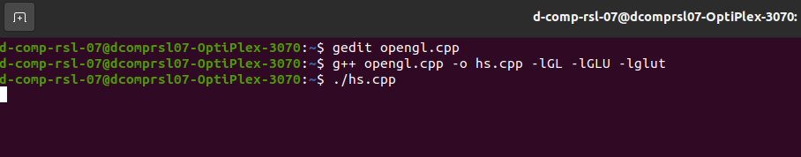

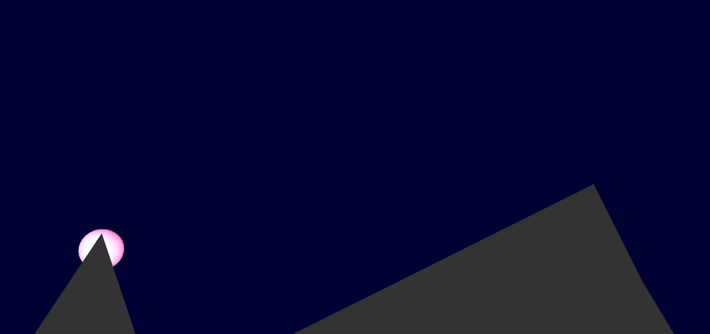

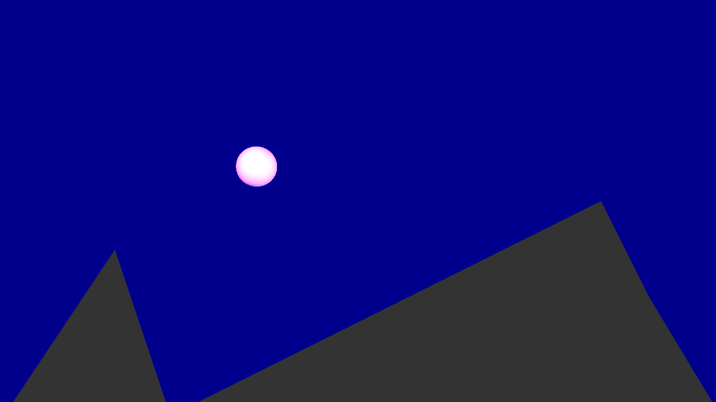

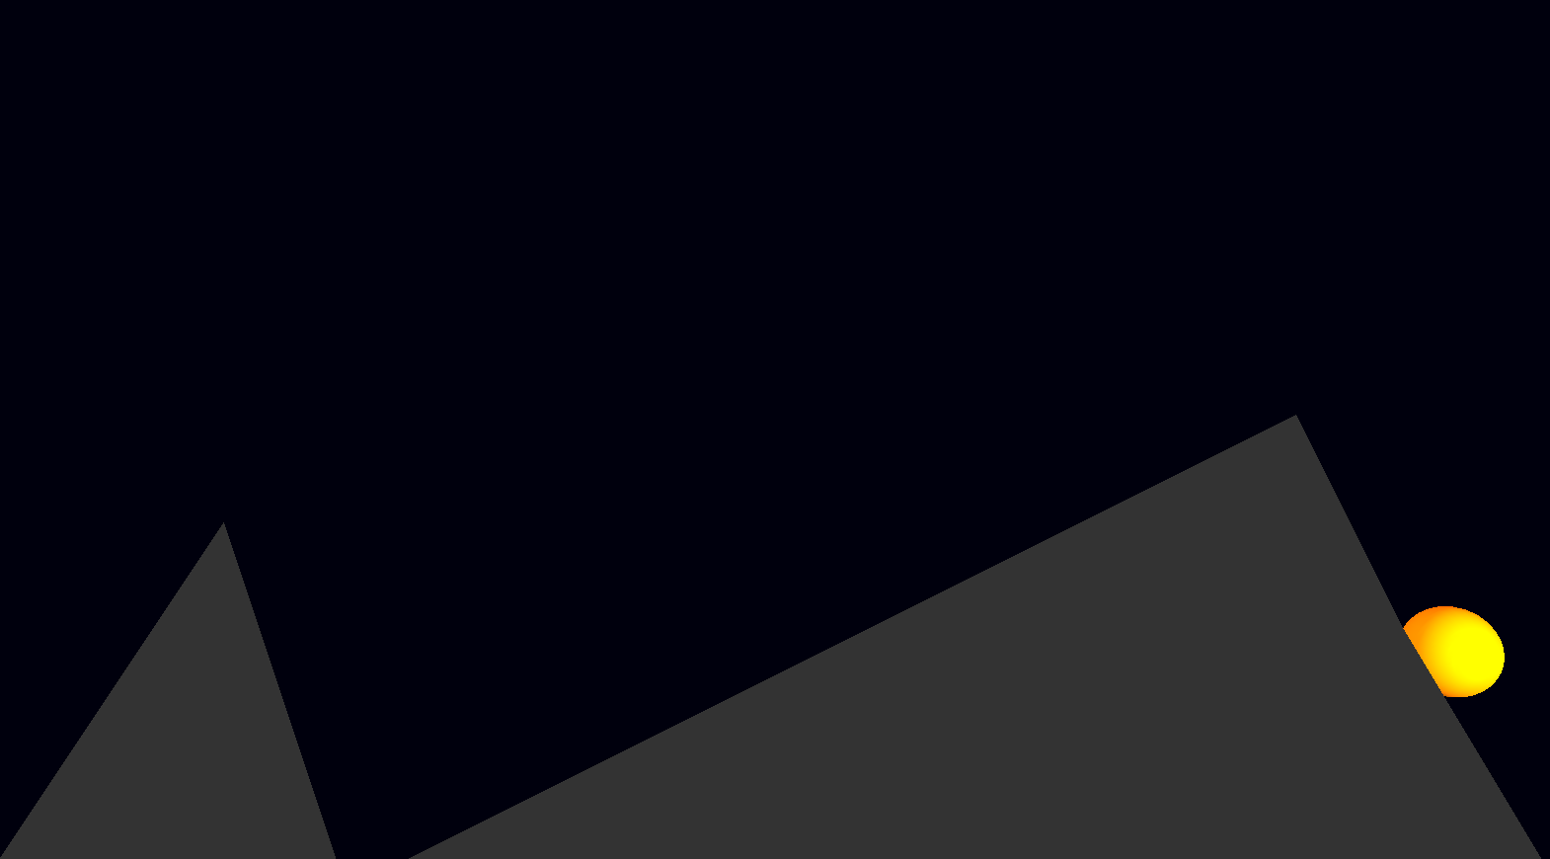

Assignment no.7

Title:- Write a C++ program to implement bouncing ball using Sine wave form. Apply the concept of Polymorphism.
Program:-
#include<iostream>
#include<graphics.h>
#include<math.h>
using namespace std;
class Base
{
public:
void connect()
{
float x=1,y=0.00000,j=0.5,count=0.1;
float r=15;
setcolor(9);
line(0,215,650,215);
sleep(1);
for(int k=0;k<=7;k++)
{
for(float i=90;i<270;i+=10)
{
y=cos(((i*22/7)/180))/j;
if(y>0)
y=-y;
x+=5;
setcolor(9);
circle(x,y*100+200,r);
floodfill(x,y*100+200,14);
delay(200);
setcolor(0);
circle(x,y*100+200,r);
floodfill(x,y*100+200,0);
}
}
}
};
class Derived:public Base
{
public:
void connect()
{
cout<<"You connect the wronge function ...\n"<<endl;
cout<<"Go back to Right function...\n"<<endl;
}
};
int main()
{ int gd=DETECT,gm;
initgraph(&gd,&gm,NULL);
Base *ptrToBase;
Derived objToDerived;
ptrToBase=&objToDerived;
ptrToBase->connect();
getch();
return 0;
}
Output:-
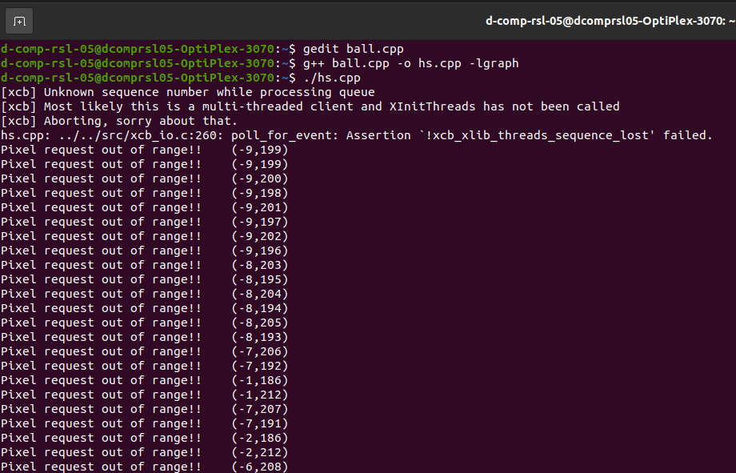

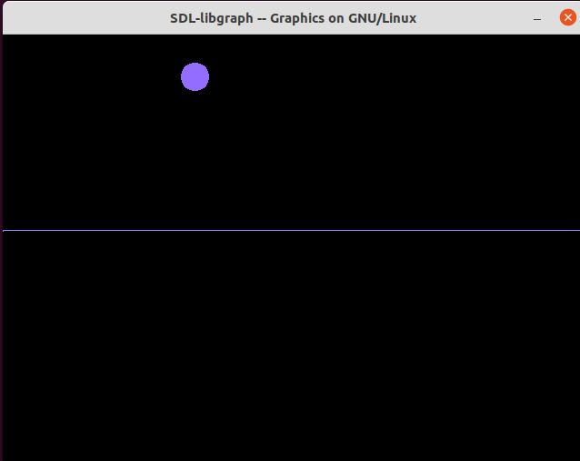

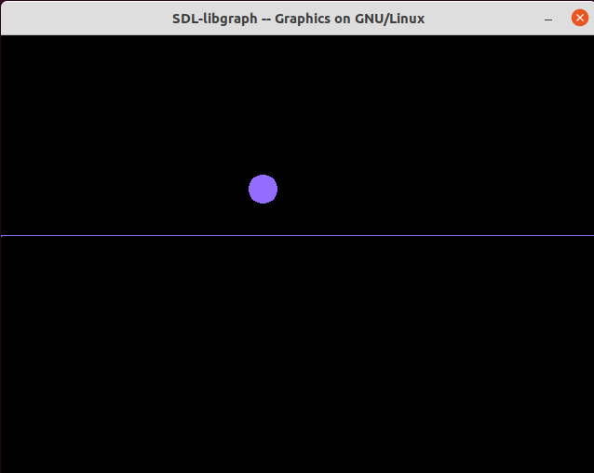

MINI PROJECT REPORT
On
“Simple Village Using OpenGL”
A Report Submitted for A mini project for computer graphics lab in 3rd Semester of Second Year Computer Engineering.
Second Year (COMPUTER ENGINEERING)
Academic Year 2022-23
Submitted by-
No | Name of the  student | Roll No
1. | Vaishnavi Ganesh Bhokare | S211021
2. | Harshada Satish  Daundkar | S211037


Zeal Education Society's
Zeal College of Engineering & ResearchNarhe,
Pune – 411041
Department of Computer Engineering
Zeal Education Society’s
Zeal College of Engineering & Research Department of Computer
Engineering

CERTIFICATE

Certified that the project entitled “Simple Village Using OpenGL” is a bona fide work carried out by Vaishnavi Ganesh Bhokare(S211021), Harshada Satish Daundkar(S211037). It is certified that all corrections/suggestions indicated for Internal Assignment have been incorporated in the report. The project report has been approved as it satisfies the academic requirements in respect of Project work prescribed for the Bachelor of Engineering Degree.

Prof. Rupali Jadhav Prof. A. V. Mote
Project Guide H. O. D

ACKNOWLEDGEMENT

We take this opportunity to thank our project guide Prof. Rupali Jadhav mam
and Head of the department Prof. A. V. Mote mam for their valuable guidance
and for providing all the necessary facilities, which were indispensable in the
completion of this project report. We are also thankful to all the staff members
of Computer Engineering Department for their valuable time,
support, comments, suggestions and persuasion. We would also like to thank the
institute for providing the required facilities, Internet access and important books.

INDEX

Sr. No | CONTENT | Page No.
1. | Abstract | 5
2. | Software Requirement | 6
3. | Introduction | 7
4. | Problem Statement | 8
5. | Objective And Outcome | 8
6. | Implementation Code | 8-17
7. | Output | 18-20
8. | Conclusion | 21
9. | References | 21

ABSTRACT

This project is about the creation of Simple Village We are implementing it using different primitives available in OpenGL library and combining them together in a required manner.
A simple village is a mini project in computer graphics which is simple, good looking and useful. We have mainly created some artifacts in this mini project, like a home, sun, clouds, trees. In the project a house is present in a small village and in the sky couple of clouds will be passing in the sky and there are few trees and in the house we can turn off the light and turn on the light whenever it is needed and it has got two modes in it day mode and the night mode.
It highlights the key features of the data structures and its high quality efficiency that is obtained on its usage in the application program. This project consists of Simple Village Day-Night Scenario which is constructed by using different primitives available in OpenGL library. It illustrates the role of different calllback functions that provides easier way to accomplish our project in an effective manner. The project has been implemented by efficiently using the data structures to obtain the optimized results and also various functions and features that are made available by the OpenGL software package have been utilized effectively.

SOFTWARE AND HARDWARE REQUIREMENT

❖ Ubuntu (Linux OS)
❖ Programming languages:
• C++
❖ Software: GNU G++
❖ System: Ubuntu 20.04 LTS

INTRODUCTION
Computers have become a powerful tool for the rapid and economical production of pictures. There is virtually no area in which graphical displays cannot be used to some advantage, and so it is not surprising to find the use of computer graphics so widespread. Although early applications in engineering and science had to rely on expensive and cumbersome equipment, advances in computer technology have made interactive computer graphics a practical tool. Today, we find computer graphics used routinely in such diverse areas as science, engineering, medicine, business, industry, government, art, entertainment, advertising, education, and training.
Computer graphics are graphics created using computers and, more generally, the representation and manipulation of image data by a computer. The development of computer graphics has made computers easier to interact with, and better for understanding and interpreting many types of data. Developments in computer graphics have had a profound impact on many types of media and have revolutionized animation, movies and the video game industry.
A major use of computer graphics is in design processes. particularly for engineering and architectural systems, but almost all products are now computer designed. Generally referred to as CAD, computer-aided design methods are now routinely used in the design of buildings, automobiles, aircraft, watercraft, spacecraft, computers, textiles, and many other products. Here we have used “OpenGL” as the graphics software system to implement our mini project, “Simple Village”. Now let us have a quick look at OpenGL. It is a library for doing computer graphics. By using it, we can create interactive applications which render high-quality colour images composed of 3D geometric objects and images. OpenGL is a window and operating system independent. As such, the part of our application which does rendering is platform independent. However, in order for OpenGL to be able to render, it needs a window to draw into. Generally, this is controlled by the windowing system on whatever platform we are working on. As OpenGL is platform independent, we need some way to integrate OpenGL into each windowing system. Every windowing system where OpenGL is supported has additional API calls for managing OpenGL windows, colour maps and other features. These additional APIs are platform dependent. For the sake of simplicity we are using an additional freeware library for simplifying interacting with windowing systems GLUT. GLUT the OpenGL Utility Toolkit is a library to make writing OpenGL programs regardless of windowing systems much easier.
Problem Statement : Design and implement Simple Village using open source graphics library.
Objective : To understand the concept of OpenGL and designing the animation based mini project.
Outcome : Implementing Simple Village using OpenGL API.
Implementation Code:-
#include<iostream>
#include<GL/glut.h>
#include <GL/gl.h>
#define SPEED 30.0
using namespace std;
float i=0.0,m=0.0,n=0.0,o=0.0,c=0.0,b=0.0;
float p=0.75,q=0.47,r=0.14;
float e=0.90,f=0.91,g=0.98;
int count=0;
int light=1,day=1,plane=0,xm=900;
char ch;
void declare(char *string)
{
while(*string)
glutBitmapCharacter(GLUT_BITMAP_TIMES_ROMAN_24, *string++);
}
void draw_pixel(GLint cx, GLint cy)
{
glBegin(GL_POINTS);
glVertex2i(cx,cy);
glEnd();
}
void plotpixels(GLint h,GLint k, GLint x,GLint y)
{
draw_pixel(x+h,y+k);
draw_pixel(-x+h,y+k);
draw_pixel(x+h,-y+k);
draw_pixel(-x+h,-y+k);
draw_pixel(y+h,x+k);
draw_pixel(-y+h,x+k);
draw_pixel(y+h,-x+k);
draw_pixel(-y+h,-x+k);
}
void draw_circle(GLint h, GLint k, GLint r)
{
GLint d=1-r, x=0, y=r;
while(y>x)
{
plotpixels(h,k,x,y);
if(d<0) d+=2*x+3;
else
{
d+=2*(x-y)+5;
--y;
}
++x;
}
plotpixels(h,k,x,y);
}
void draw_object()
{
int l;
if(day==1)
{
//sky
glColor3f(0.0,0.9,0.9);
glBegin(GL_POLYGON);
glVertex2f(0,380);
glVertex2f(0,700);
glVertex2f(1100,700);
glVertex2f(1100,380);
glEnd();
//sun
for(l=0;l<=35;l++)
{
glColor3f(1.0,0.9,0.0);
draw_circle(100,625,l);
}
//cloud1
for(l=0;l<=20;l++)
{
glColor3f(1.0,1.0,1.0);
draw_circle(160+m,625,l);
}
for(l=0;l<=35;l++)
{
glColor3f(1.0,1.0,1.0);
draw_circle(200+m,625,l);
draw_circle(225+m,625,l);
}
for(l=0;l<=20;l++)
{
glColor3f(1.0,1.0,1.0);
draw_circle(265+m,625,l);
}
//cloud2
for(l=0;l<=20;l++)
{
glColor3f(1.0,1.0,1.0);
draw_circle(370+m,615,l);
}
for(l=0;l<=35;l++)
{
glColor3f(1.0,1.0,1.0);
draw_circle(410+m,615,l);
draw_circle(435+m,615,l);
draw_circle(470+m,615,l);
}
for(l=0;l<=20;l++)
{
glColor3f(1.0,1.0,1.0);
draw_circle(500+m,615,l);
}
//grass
glColor3f(0.6,0.8,0.196078);
glBegin(GL_POLYGON);
glVertex2f(0,160);
glVertex2f(0,380);
glVertex2f(1100,380);
glVertex2f(1100,160);
glEnd();
}
else
{
//sky
glColor3f(0.0,0.0,0.0);
glBegin(GL_POLYGON);
glVertex2f(0,380);
glVertex2f(0,700);
glVertex2f(1100,700);
glVertex2f(1100,380);
glEnd();
//moon
int l;
for(l=0;l<=35;l++)
{
glColor3f(1.0,1.0,1.0);
draw_circle(100,625,l);
}
//grass
glColor3f(0.0,0.3,0.0);
glBegin(GL_POLYGON);
glVertex2f(0,160);
glVertex2f(0,380);
glVertex2f(1100,380);
glVertex2f(1100,160);
glEnd();
}
//Ground
glColor3f(0.0,0.3,0.0);
glBegin(GL_POLYGON);
glVertex2f(-600,0);
glVertex2f(-600,185);
glVertex2f(1100,185);
glVertex2f(1100,0);
glEnd();
//tree
glColor3f(0.9,0.2,0.0);
glBegin(GL_POLYGON);
glVertex2f(280,185);
glVertex2f(280,255);
glVertex2f(295,255);
glVertex2f(295,185);
glEnd();
for(l=0;l<=30;l++)
{
glColor3f(0.0,0.5,0.0);
draw_circle(270,250,l);
draw_circle(310,250,l);
}
for(l=0;l<=25;l++)
{
glColor3f(0.0,0.5,0.0);
draw_circle(280,290,l);
draw_circle(300,290,l);
}
for(l=0;l<=20;l++)
{
glColor3f(0.0,0.5,0.0);
draw_circle(290,315,l);
}
//tree 1
glColor3f(0.9,0.2,0.0);
glBegin(GL_POLYGON);
glVertex2f(100,135);
glVertex2f(100,285);
glVertex2f(140,285);
glVertex2f(140,135);
glEnd();
for(l=0;l<=40;l++)
{
glColor3f(0.0,0.5,0.0);
draw_circle(40,280,l);
draw_circle(90,280,l);
draw_circle(150,280,l);
draw_circle(210,280,l);
draw_circle(65,340,l);
draw_circle(115,340,l);
draw_circle(175,340,l);
}
for(l=0;l<=55;l++)
{
glColor3f(0.0,0.5,0.0);
draw_circle(115,360,l);
}
//chim
glColor3f(0.35,0.0,0.0);
glBegin(GL_POLYGON);
glVertex2f(540,330);
glVertex2f(540,430);
glVertex2f(960,430);
glVertex2f(960,330);
glEnd();
//home
glColor3f(p,q,r);
glBegin(GL_POLYGON);
glVertex2f(550,100);
glVertex2f(550,330);
glVertex2f(950,330);
glVertex2f(950,100);
glVertex2f(850,100);
glVertex2f(850,250);
glVertex2f(650,250);
glVertex2f(650,100);
glEnd();
//window border
glColor3f(0.35,0.0,0.0);
glBegin(GL_POLYGON);
glVertex2f(595,205);
glVertex2f(595,285);
glVertex2f(675,285);
glVertex2f(675,205);
glEnd();
glBegin(GL_POLYGON);
glVertex2f(825,205);
glVertex2f(825,285);
glVertex2f(905,285);
glVertex2f(905,205);
glEnd();
glBegin(GL_POLYGON);
glVertex2f(845,205);
glVertex2f(845,285);
glVertex2f(850,285);
glVertex2f(850,205);
glEnd();
//door
glColor3f(e,f,g);
glBegin(GL_POLYGON);
glVertex2f(800,100);
glVertex2f(800,220);
glVertex2f(700,220);
glVertex2f(700,100);
glEnd();
glColor3f(0.35,0.0,0.0);
glBegin(GL_POLYGON);
glVertex2f(760,120);
glVertex2f(760,200);
glVertex2f(700,220);
glVertex2f(700,100);
glEnd();
//window
glColor3f(e,f,g);
glBegin(GL_POLYGON);
glVertex2f(600,210);
glVertex2f(600,280);
glVertex2f(670,280);
glVertex2f(670,210);
glEnd();
glBegin(GL_POLYGON);
glVertex2f(830,210);
glVertex2f(830,280);
glVertex2f(900,280);
glVertex2f(900,210);
glEnd();
glColor3f(0.35,0.0,0.0);
glBegin(GL_POLYGON);
glVertex2f(620,210);
glVertex2f(620,280);
glVertex2f(625,280);
glVertex2f(625,210);
glEnd();
glBegin(GL_POLYGON);
glVertex2f(650,210);
glVertex2f(650,280);
glVertex2f(655,280);
glVertex2f(655,210);
glEnd();
glColor3f(0.35,0.0,0.0);
glBegin(GL_POLYGON);
glVertex2f(850,205);
glVertex2f(850,285);
glVertex2f(855,285);
glVertex2f(855,205);
glEnd();
glBegin(GL_POLYGON);
glVertex2f(880,205);
glVertex2f(880,285);
glVertex2f(885,285);
glVertex2f(885,205);
glEnd();
glFlush();
}
void idle()
{
if(light==0 && (i>=0 && i<=1150))
{
i+=SPEED/10;
m+=SPEED/150;
n-=2;
o+=0.2;
c+=2;
}
if(light==0 && (i>=2600 && i<=3000))
{
i+=SPEED/10;
m+=SPEED/150;
n-=2;
o+=0.2;
c+=2;
}
if(light==0)
{
i=i;
m+=SPEED/150;
n-=2;
o+=0.2;
c+=2;
}
if(count<=3)
{
glClearColor(1.0,1.0,1.0,1.0);
i+=SPEED/10;
b+=SPEED/10;
m+=SPEED/150;
n-=2;
o+=0.2;
c+=2;
}
if(i>1900)
i=800.0;
if(m>1100)
m=0.0;
glutPostRedisplay();
}
void mouse(int btn,int state,int x,int y)
{
if(btn==GLUT_LEFT_BUTTON && state==GLUT_UP)
exit(0);
}
void keyboardFunc( unsigned char key, int x, int y )
{
switch( key )
{
case 'd':
case 'D':
day=1;
p=0.75;
q=0.47;
r=0.14;
break;

case 'n':
case 'N':
day=0;
p=0.52;
q=0.37;
r=0.26;
break;
case 'l':
case 'L':
e=0.90;
f=0.91;
g=0.98;
break;
case 'f':
case 'F':
e=0.0;
f=0.0;
g=0.0;
break;
};
}
void myinit()
{
glClearColor(1.0,1.0,1.0,1.0);
glColor3f(0.0,0.0,1.0);
glPointSize(2.0);
glMatrixMode(GL_PROJECTION);
glLoadIdentity();
gluOrtho2D(0.0,1100.0,0.0,700.0);
}
void display()
{
glClear(GL_COLOR_BUFFER_BIT);
draw_object();
glFlush();
}
int main(int argc,char** argv)
{
int c_menu;
cout<<"Project by CSEMiniProjects.com\n";
cout<<"--------------------------------------------------------------------------------";
cout<<" Simple Village "<<endl;
cout<<"--------------------------------------------------------------------------------\n\n";
cout<<"Press 'd' or 'D' to make it day. \n\n";
cout<<"Press 'n' or 'N' to make it night. \n\n";
cout<<"Press 'l' or 'L' to turn On the lights. \n\n";
cout<<"Press 'f' or 'F' to turn Off the lights. \n\n";
cout<<"Press RIGHT MOUSE BUTTON to display menu. \n\n";
cout<<"Press LEFT MOUSE BUTTON to quit the program. \n\n\n";
cout<<"Press any key and Hit ENTER.\n";
cin>>ch;
glutInit(&argc,argv);
glutInitDisplayMode(GLUT_SINGLE|GLUT_RGB);
glutInitWindowSize(1100.0,700.0);
glutInitWindowPosition(0,0);
glutCreateWindow("Simple Village");
glutDisplayFunc(display);
glutIdleFunc(idle);
glutKeyboardFunc(keyboardFunc);
glutMouseFunc(mouse);
myinit();
glutAddMenuEntry("Aeroplane",1);
glutAddMenuEntry("Comet",2);
glutAttachMenu(GLUT_RIGHT_BUTTON);
glutMainLoop();
return 0;
}

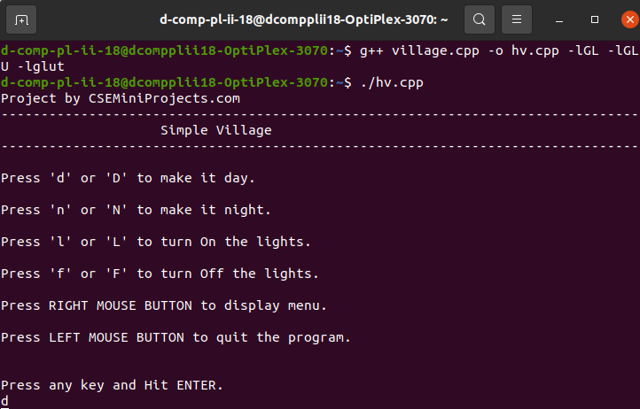
Output:-

1)Day Mode with clouds in the sky.
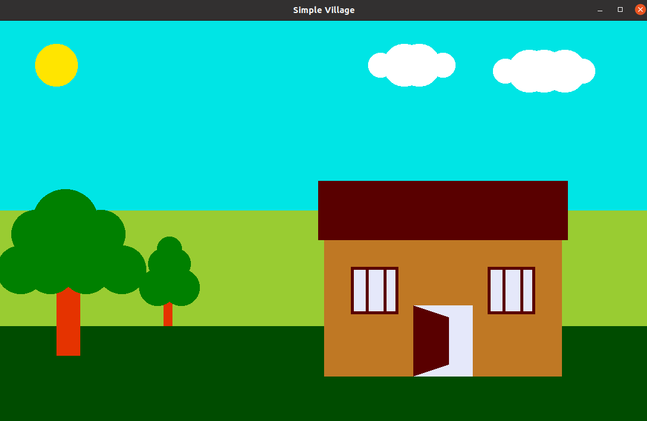
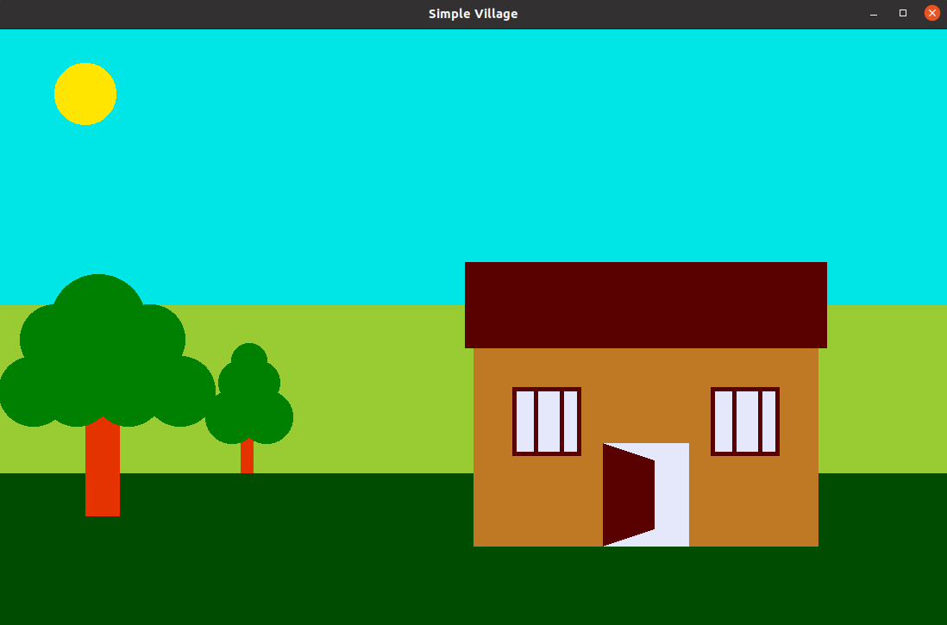
2)Day mode without clouds in the sky.

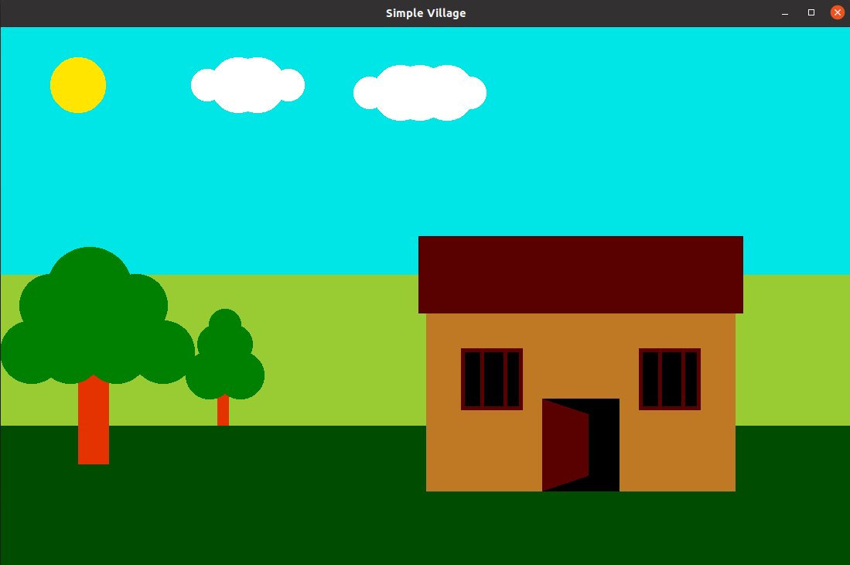
3)Day mode with Light OFF in the house.
4)Night mode with light ON in the house.
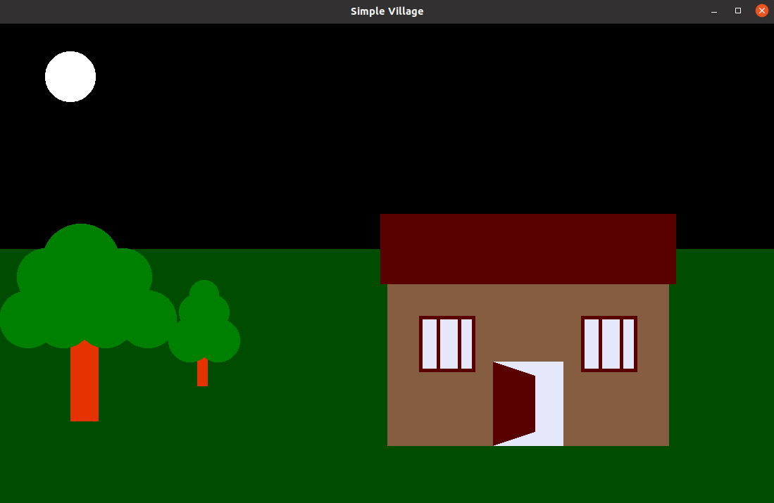
5)Night mode with light OFF in the house.
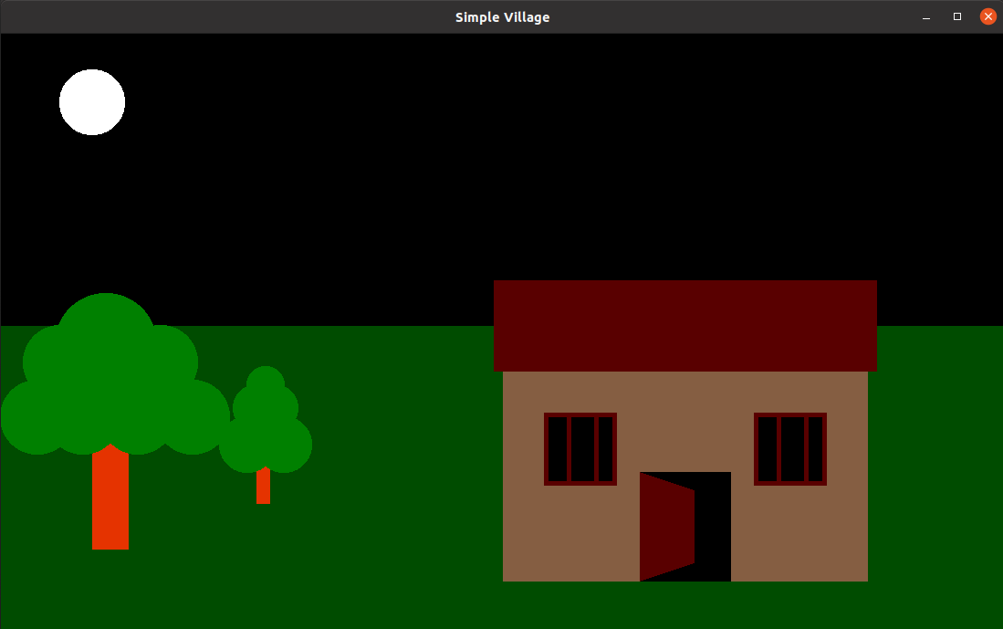
CONCLUSION

While developing a system a conscious effort has been made to create and develop a software package, making use of available tools, techniques and resources – that will generate the proper system cases.

While making the system an eye has been kept on making it as user friendly as such one may hope that the system will be acceptable to any user and will adequately meet his/her needs. As in case of any system development process where are number of short comings, there have been some short comings in the development of this system also.

References:-

Source Code:- https://drive.google.com/file/d/1emd5

OpenGL : 1) https://www.opengl.org/
2) https://en.wikipedia.org/wiki/OpenGL
3) https://www.khronos.org/opengl/wiki/Getting_Starte

